PROJECT REPORT TEMPLATE

INTRODUCTION :

OVERVIEW :

***This is the process that facilitates easy procurement of desired merchandise from retail stores for the sole purpose of personal consumption. It is an elaborate process that includes multiple steps for attracting the customer to the store and then meeting their needs and requirements.***

PURPOSE :

Retail management optimizes internal processes such as inventory management, offline and online storefronts, warehouse operations, payment and accounting, and human resources. Retail management improves overall company cohesion. Retail store management improves customer experience and boosts customer satisfaction.

EMPATHY MAP :

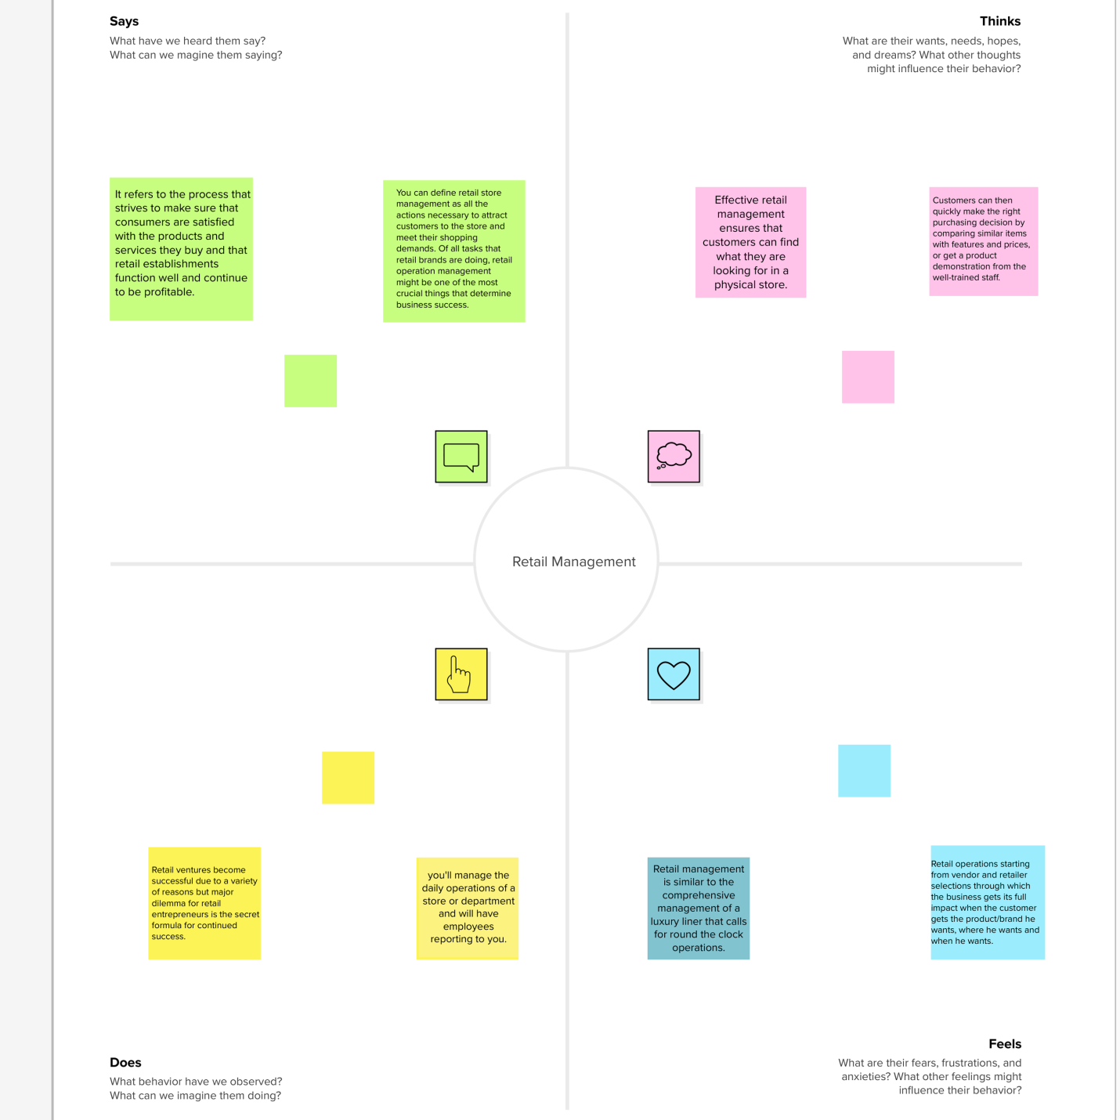

IDEATION & BRAINSTORMING MAP :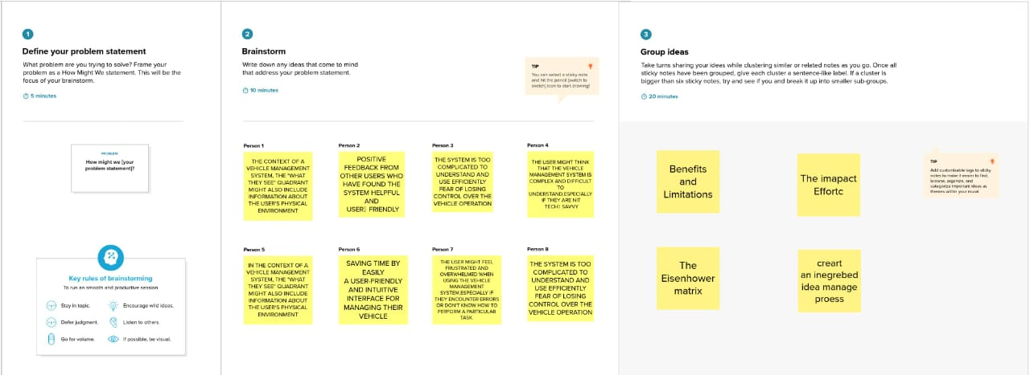

ACTIVITY & SCREENSHOR :

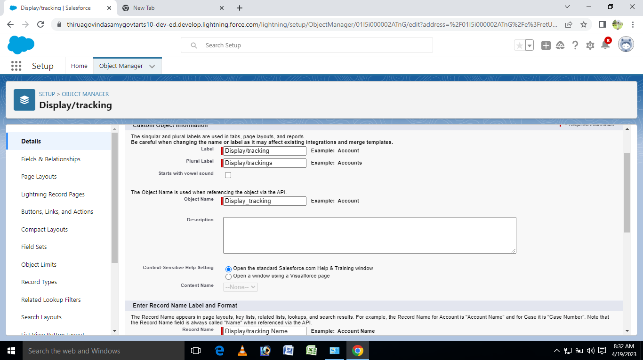

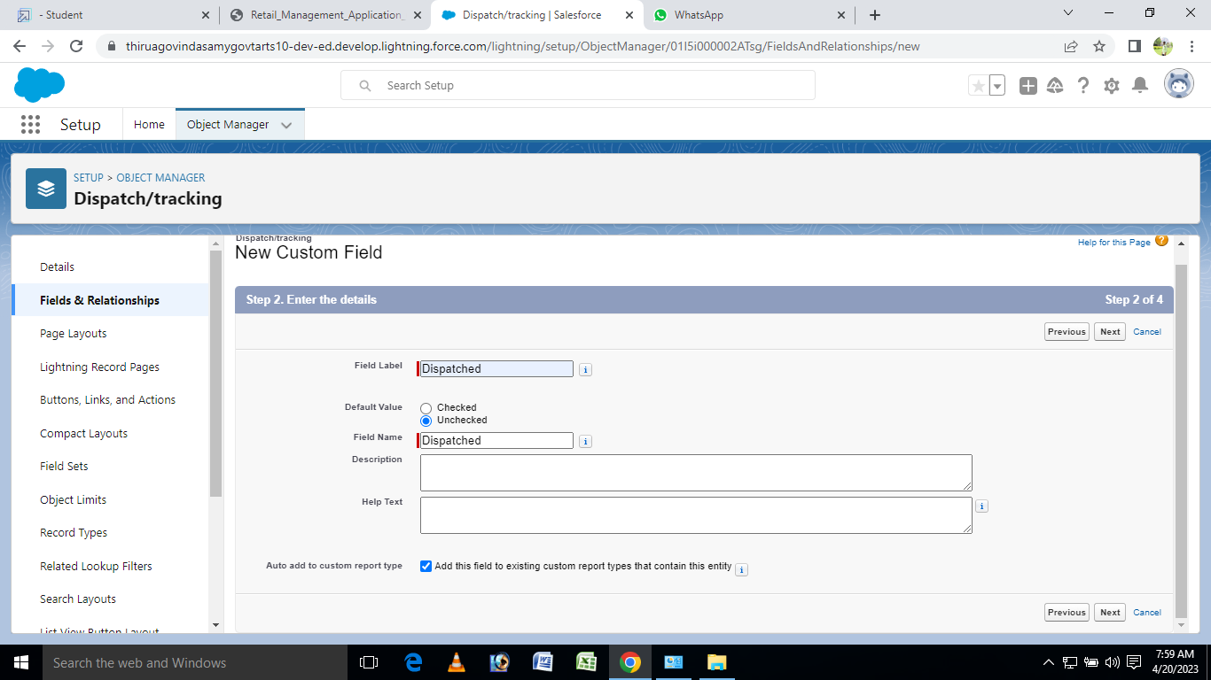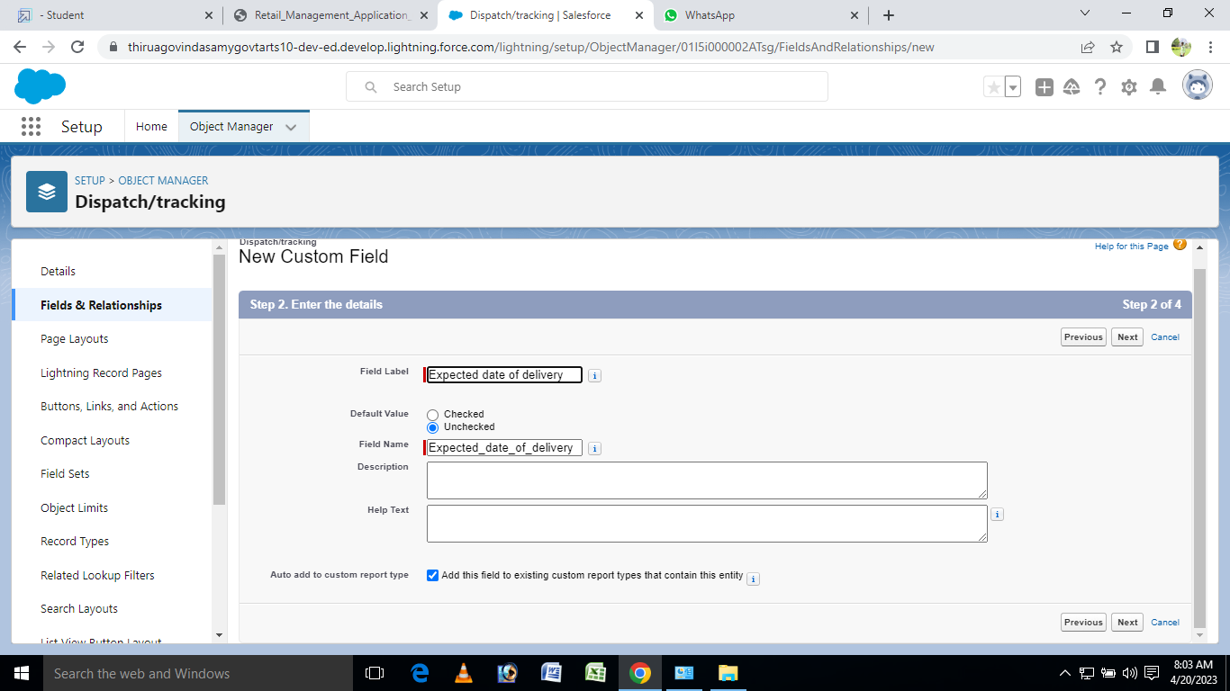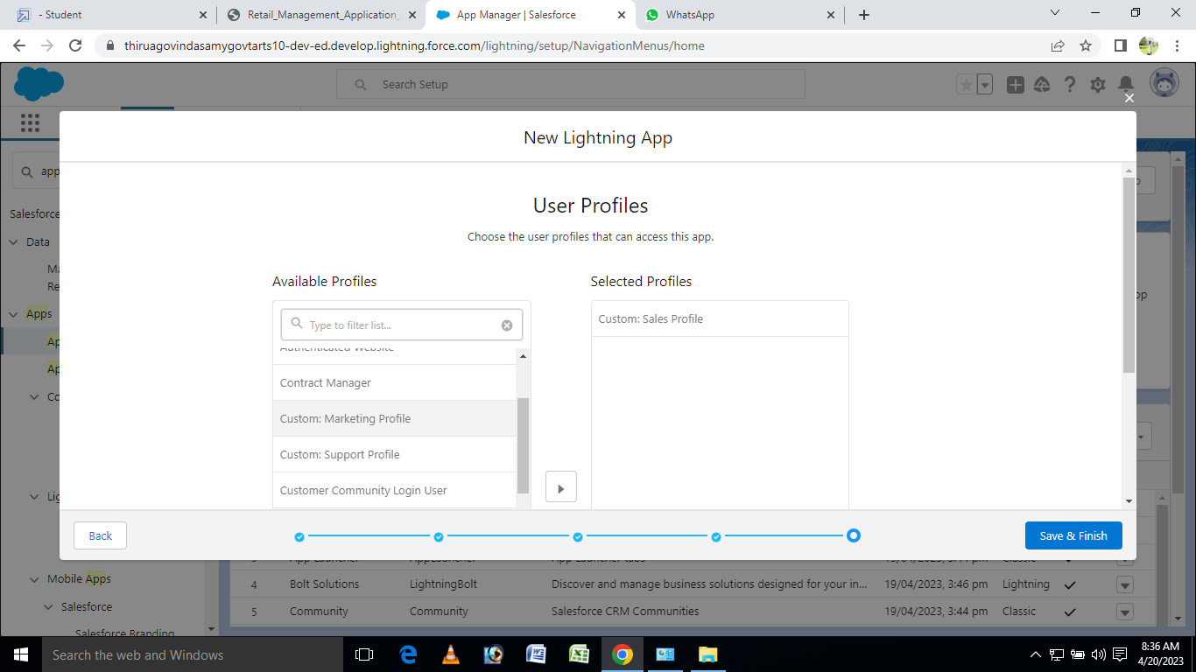

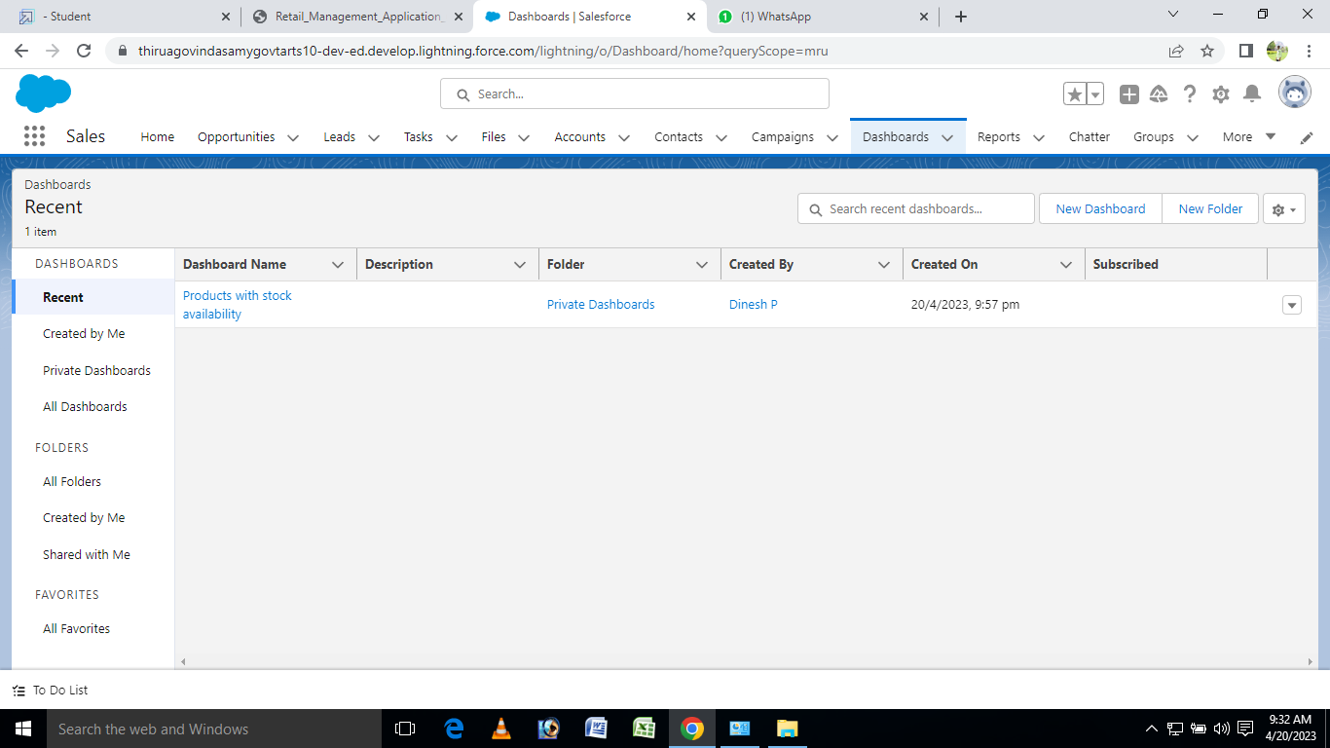

TEAM DETAILS:

Team Leader: AKASH S

Team member1:AKASH T

Team member2:BAGAVATHI P

Team member3:DINESH P

ADVANTAGES & DISADVANTAGES :

**ADVANTAGES:**

The biggest advantage of retailing is that it is a cash business implying that a retailer will always sell goods on cash to its customers and since wholesaler gives goods to retailers on credit of 30 to 60 days it is the retailer who enjoys liquidity as he or she is selling goods in cash and getting credit from wholesalers.

**DISADVANTAGES:**

The biggest problem with retail business is that profit margins of this business is fixed which ranges from 5 to 20 percent depending upon the brand of the product which retailer is selling and also unlike wholesaler who can expand business in order to achieve economies of scale in case of retailing such thing is not possible.

CONCLUSION :

The main purpose for developing this project can helps to Retail management etc.